Code Fury

Software User Manual (SUM)

Contents

Contents 2

1. Scope 3

1.1 Identification 3

1.2 System overview 3

1.3 Document overview 3

2. Referenced documents 3

3. Software summary 3

3.1 Software application 3

3.2 Software inventory 3

3.3 Software environment 3

3.4 Software organization and overview of operation 3

3.5 Assistance and problem reporting 4

4. Access to the software 4

4.1 First-time user of the software 4

4.1.1 Installation and setup 4

5. Processing reference guide 4

5.1 Capabilities 4

5.2 Messages 8

6. Notes 9

1. Scope
   1. Identification

This document pertains to system version 1.0.0.

* 1. System overview

This system aims to provide users with an interactive map of the United States marked with areas that satisfy their lifestyle preferences.

* 1. Document overview

This document outlines procedures for operating the software. Features are described at the component level.

1. Referenced documents

Leaving this section for future use.

1. Software summary

The purpose of the software is to determine which areas of the United States align with the user’s lifestyle preferences. The user inputs their preferences by activating the components described below. Areas that match are marked by pins and given descriptions of how closely they match the initial criteria.

* 1. Software application

Our software is targeted at users who are interested in determining which areas of the United States align with their lifestyle preferences.

* 1. Software inventory

It is not necessary to install any files to use the software. The user needs only to open the webpage in their browser (of course, a web browser is necessary).

* 1. Software environment

The following is an itemization of the resources necessary for software operation:

* A relatively up to date web browser [replace this with browser versions]. Possible web browsers include Chrome, Firefox, and Safari.
* Internet access
  1. Software organization and overview of operation

The following is a sequence of steps that defines software operation from the user’s point of view:

1. First, open the search criteria menu. This is done by clicking the hamburger icon in the top left corner of the web page.
2. Next, activate the search components that are important to you. If there is a dropdown menu for that component, select the condition(s) that most align(s) with your preferences.
3. Then, when you have finished inputting your preferences, press the search button and wait for the results to be returned. Note: This may take up to 10 seconds depending on the query.
4. Finally, if you are interested in whya particular area was given a marker, hover over that marker to see how closely that area matches your initial criteria.
   1. Assistance and problem reporting

To obtain assistance or report problems contact a development team member:

* Dan (end1@umbc.edu)
* Kyle (colem1@umbc.edu)
* Rushmie (rushmie1@umbc.edu)
* Jon (danko1@umbc.edu)
* Tyler (karl4@umbc.edu)
* Doug (dgess@umbc.edu)
* Brian (seipp1@umbc.edu)

1. Access to the software

Accessing the software only requires one step. The user needs only to enter the site URL, codefury.tk, into their browser’s address bar.

* 1. First-time user of the software

### Installation and setup

No installation is required for using our software (apart from the installation of a web browser). For more information on how to access the site, refer to section 4.

1. Processing reference guide
   1. Capabilities

The following is an itemization of all software components and descriptions of how they are to be used:

* The search criteria menu contains the components that let the user input their preferences. To open the menu, click the hamburger icon in the top left corner of the screen. To close the menu, click the X in the top right corner.

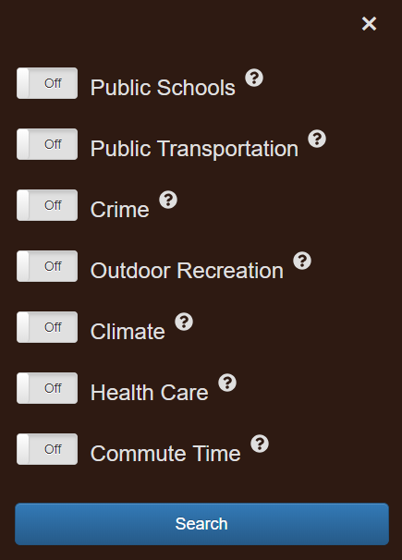

* The public schools, public transportation, and crime components all work the same way. To activate these components, make sure the on/off button is on the on position. Then, select the condition from the dropdown menu that most aligns with your preferences.

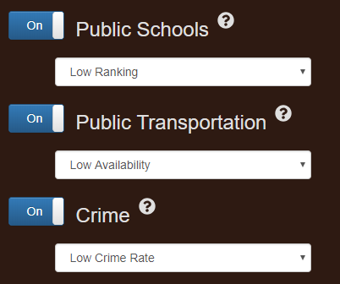

* The outdoor recreation component works in roughly the same way as the other components, but instead of a dropdown menu it uses buttons to set further conditions. When using this component, turn on all subcomponents that correspond to recreational activities you are interested in.

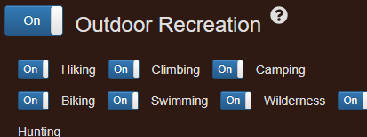

* Again, the climate component works in roughly the same way as the others. The difference here is that you must select conditions from three dropdown menus instead of one.

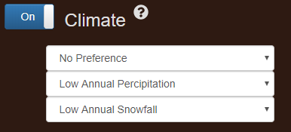

* The healthcare component works the same way as the first three. To use this component, set the on/off button to the on position and select the condition from the dropdown menu that most aligns with your preferences.

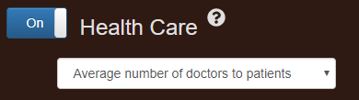

* To use the commute time component, set the on/off button to the on position and slide the slider to an average commute time that you consider acceptable.

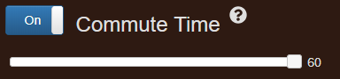

* Each component has a help button in the upper right-hand corner. These help buttons contain information about how each component narrows the search.



* The active criteria bar displays all search criteria that are set to the on position. It is located at the top of the webpage above the map display.



* The map display is located at the center of the webpage and is where the results will be displayed.

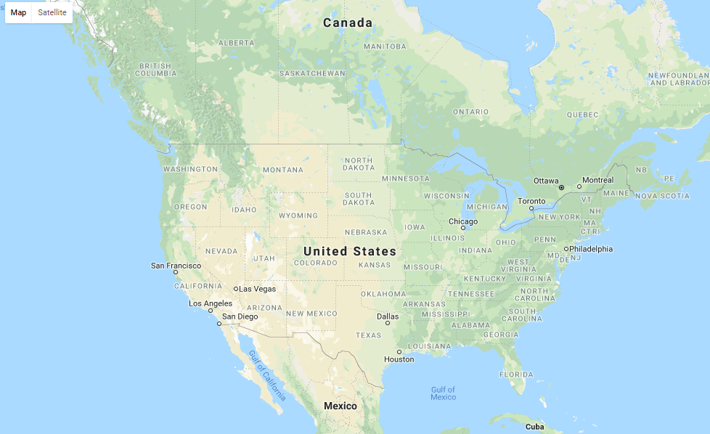

* Each result will be represented as a pin (or possibly a cluster of pins) on the map display. Hovering over a pin will display additional information about how closely that result matches the initial search criteria. Clicking on a cluster of pins will zoom in to a level appropriate for viewing all pins that comprise it.

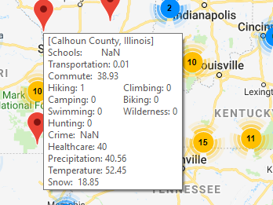

* 1. Messages

The following are the help messages displayed when the user clicks on the respective help buttons.

* When activated, search results are filtered on public school ranking. Low Ranking: Graduation rate less than 33rd percentile of national rates. Medium Ranking: Graduation rate between 33rd percentile and 66th percentile of national rates. High Ranking: Graduation rate greater than 66th percentile of national rates. Results of searches for low ranked schools include medium and high ranked schools. Likewise, results of searches for medium ranked schools include high ranked schools.
* When activated, search results are filtered on availability of public transportation. Low Availability: Less than 1% of the local population commutes with public transportation. Medium Availability: Between 1% and 7% of the local population commutes with public transportation. High Availability: Greater than 7% of the local population commutes with public transportation. Results of searches for low availability include areas with medium and high availability. Likewise, results of searches for medium availability include areas with high availability.
* When activated, search results are filtered on crime rate (violent crimes per 100,000 people). Low Crime Rate: Crime rate less than 33rd percentile of national rates. Average Crime Rate: Crime Rate between 33rd and 66th percentile of national rates. Results of searches for areas with average crime rates include areas with low crime rates.
* When activated, search results are filtered on availability of outdoor recreation activities. Only locations that have one or more of the enabled activities are returned by the search.
* When activated, search results are filtered on climate type. "No preference" will not narrow the search. Colder corresponds to below the 50th percentile, while hotter corresponds to above the 50th percentile. Low, medium, and high annual precipitation correspond to below the 33rd percentile, between the 33rd and 66th percentiles, and above the 66th percentile respectively. Low, medium, and high annual snowfall correspond to below the 33rd percentile, between the 33rd and 66th percentiles, and above the 66th percentile respectively. Searches for low conditions include results for searches for high conditions.
* When activated, search results are filtered on availability of quality health care. Average doctor to patient ratio: Doctor to patient ratio matches the national average. High doctor to patient ratio: Doctor to patient ratio is higher than the national average. Results of searches for average ratios include results of searches for high ratios.
* When activated, search results are filtered on commute time. Commute time slider value corresponds average commute time in minutes. Results of searches for average commute time value include results for searches below that value.

1. Notes

Leaving this section for future use.